[](https://vk.com/photo-117463599_456268280)

[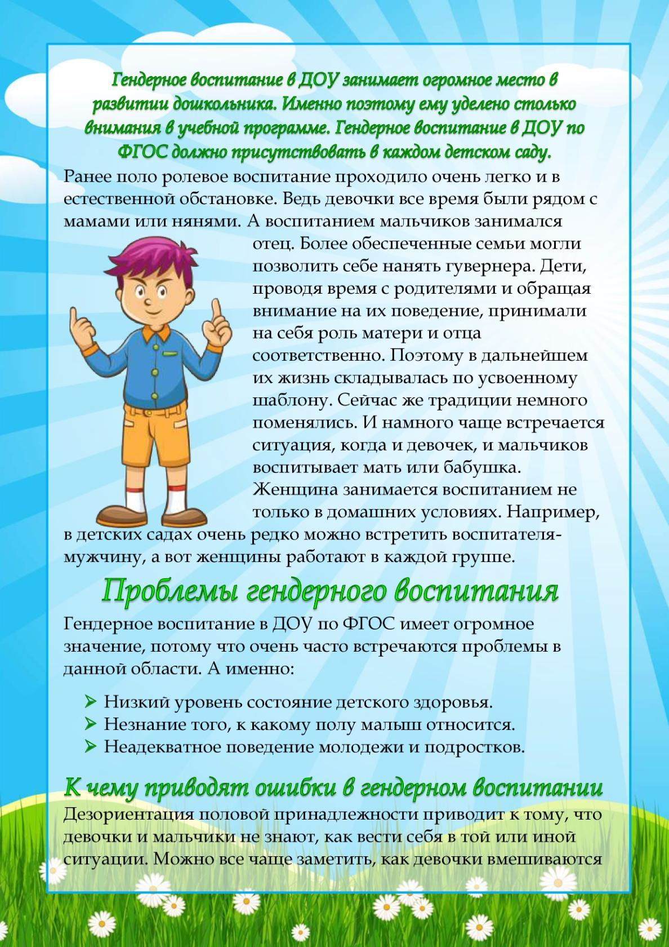](https://vk.com/photo-117463599_456268281)

[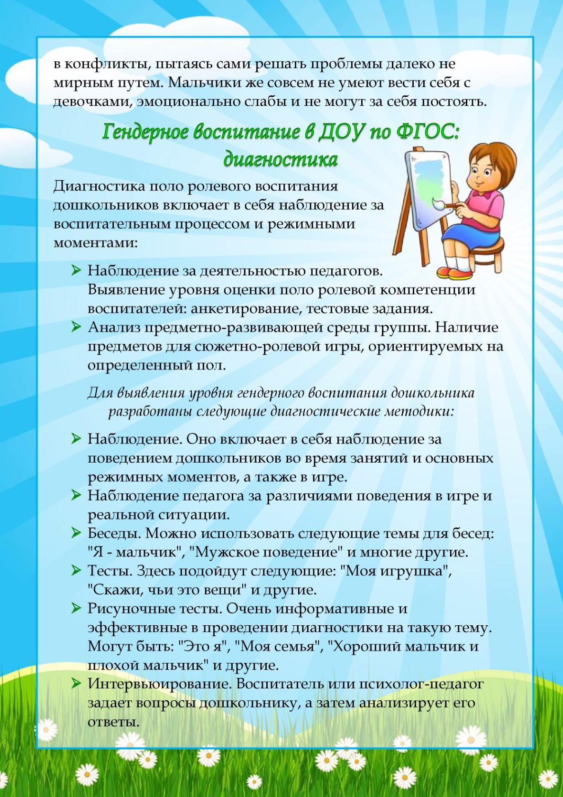](https://vk.com/photo-117463599_456268282)